# 

# 

# **QUESTION 1.**

# **INDEX:**

* **HTML CODES:-**

<!DOCTYPE html>

<html>

<head>

    <title>Index</title>

</head>

<body background="bgindex.jpg">

    <div>

        <h1><a href="Q1.Index.html">INDEX:</a></a></h1>

        <h1><a href="Q1.i..html">1. Formatting Styles and Headings </a></h1>

        <h1><a href="Q1.ii..html">2. Font Styles and Image tag</a></h1>

        <h1><a href="Q1.iii..html">3. Marquee </a></h1>

        <h1><a href="Q1.iv..html">4. Other tags</a></h1>

    </div>

</body>

</html>

* **OUTPUT:-**

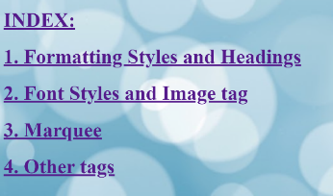

# ***Formatting Styles and Headings:***

* **HTML CODES:-**

<!DOCTYPE html>

<html>

<head>

    <title>Formatting Styles</title>

</head>

<body background="bg1.jfif">

    <h1>This is a Heading Created Using h1 tag</h1>

    <h2>This is a Heading Created Using h2 tag</h2>

    <h3>This is a Heading Created Using h3 tag</h3>

    <h4>This is a Heading Created Using h4 tag</h4>

    <h5>This is a Heading Created Using h5 tag</h5>

    <h6>This is a Heading Created Using h6 tag</h6>

<p><pre>

        <b>This sentence is created using Bold tag;</b>

        <i>This sentence is created using Italic tag;</i>

        <u>This sentence is created using Underline tag;</u>

        <strike>This sentence is created using Strike tag;</strike>

        This <sub>sentence</sub> is created using <sup>Subscript</sup> tag.

    </pre></p>

    <h1><a href="Q1.ii..html">(Go To The Next Page)</a></h1>

    <h1><a href="Q1.Index.html">(Go Back To The Index Page)</a></h1>

</body>

</html>

* **OUTPUT:-**

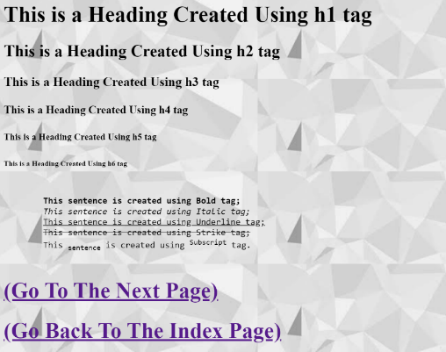

# ***Font Styles and Image Tag::***

* **HTML CODES:-**

<!DOCTYPE html>

<html>

<head>

    <title>Font Styles and image</title>

</head>

<body background="bg4.jpg">

    <h1><a name="styles&img">Font Styles and Image Tag</a></h1>

    <a href="#bold">Bold Tag</a><br>

    <a href="#italic">Italic Tag</a><br>

    <a href="#underline">Underline Tag</a><br>

    <a href="#strike">Strike Tag</a><br>

    <a href="#subscript">Subscript Tag</a><br>

    <a href="#img">Image Tag</a><br>

    <h1><a name="bold">Bold Tag</a></h1>

    <b>A computer is a machine that can be programmed to carry out sequences of arithmetic or logical

operations automatically. Modern computers can perform generic sets of operations known as programs.

       These programs enable computers to perform a wide range of tasks. A computer system is a "complete"

computer that includes the hardware, operating system (main software), and peripheral equipment needed

and used for "full" operation.This term may also refer to a group of computers that are linked and

function together, such as a computer network or computer cluster.</b>

    <h1><a name="italic">Italic Tag</a></h1>

    <i>A computer is a machine that can be programmed to carry out sequences of arithmetic or logical

operations automatically. Modern computers can perform generic sets of operations known as programs.

       These programs enable computers to perform a wide range of tasks. A computer system is a "complete"

computer that includes the hardware, operating system (main software), and peripheral equipment needed

and used for "full" operation.This term may also refer to a group of computers that are linked and

function together, such as a computer network or computer cluster.</i>

<h1><a name="underline">Underline</a></h1>

       <u>A computer is a machine that can be programmed to carry out sequences of arithmetic or logical

operations automatically. Modern computers can perform generic sets of operations known as programs.

       These programs enable computers to perform a wide range of tasks. A computer system is a "complete"

computer that includes the hardware, operating system (main software), and peripheral equipment needed

and used for "full" operation.This term may also refer to a group of computers that are linked and

function together, such as a computer network or computer cluster.</u>

        <h1><a name="strike">Strike</a></h1>

        <strike> A computer is a machine that can be programmed to carry out sequences of arithmetic or

Logical operations automatically. Modern computers can perform generic sets of operations known as

programs. These programs enable computers to perform a wide range of tasks. A computer system is a

"complete" computer that includes the hardware, operating system (main software), and peripheral

equipment needed and used for "full" operation.This term may also refer to a group of computers that

are linked and function together, such as a computer network or computer cluster.</strike>

            <h1><a name="subscript">Subscript Tag</a></h1>

            <p>A computer is a machine that can be <sub>programmed to carry out sequences of arithmetic</sub>

or <sup>logical operations automatically</sup>. Modern computers can perform generic sets of

operations known as <sub>programs</sub>. <sup>These programs enable computers to perform a wide

range of tasks.</sup> A computer system is a "complete" computer that includes <sub>the

hardware, operating system (main software), and peripheral equipment needed and used for "full"

operation</sub>. This term may also refer to <sup>a group of computers that are linked and

function together, such as a computer network or computer cluster</sup>.</p>

            <h1><a name="img">Image Tag</a></h1>

            <img src="comp.jpg"  alt="Trees" width="450" height="350"><br>

        <h1><a href="#styles&img">(Go Back To The Top)</a></h1>

        <h1><a href="Q1.iii..html">(Go To The Next Page)</a></h1>

        <h1><a href="Q1.Index.html">(Go Back To The Index Page)</a></h1>

</body>

</html>

* **OUTPUT:-**

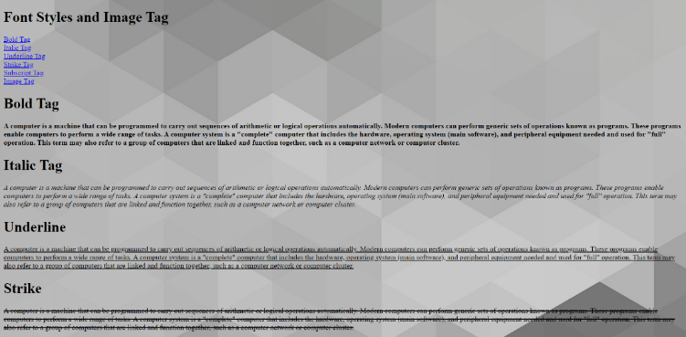

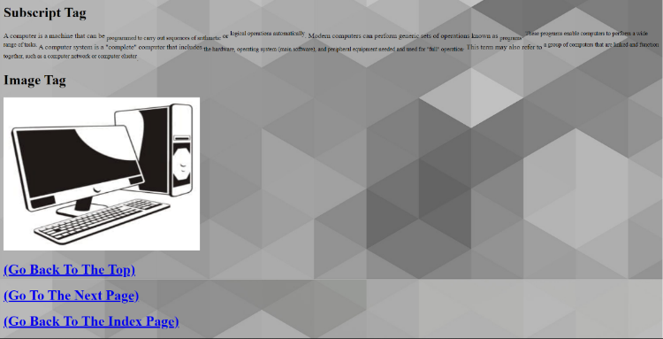

# ***Marquee: Move Text, image and hyperlink:***

* **HTML CODES:-**

<!DOCTYPE html>

<html>

<head>

    <title> marquee : move text ,image  </title>

</head>

<body background="bg2.png">

    <marquee  behavior="side" direction=" left" bgcolor="white" height="60"><b><font size="60">HTML TUTORIAL</font></b><br> </marquee>

     <img src="b&wimg.jpg"  alt="Trees" width="600" height="450"><br>

     <h1><a href="Q1.iv..html"><font color="white">(Go To The Next Page)</font></a></h1>

    <h1><a href="Q1.Index.html"><font color="white">(Go Back To The Index Page)</font></a></h1>

</body>

</html>

* **OUTPUT:-**

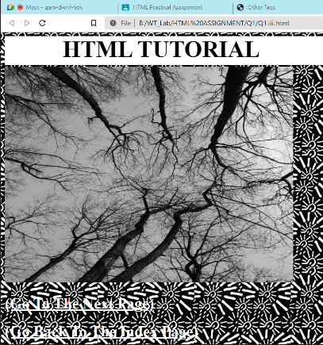

# ***Other Tags: br,hr, pre, p***

* **HTML CODES:-**

<!DOCTYPE html>

<html>

<head>

    <title>Other Tags</title>

</head>

<body background="bg3.jfif">

    <h1 ><u>THE FIRST TAG IS BR TAG </u></h1>

    <b>BR IS USED TO BREAK THE LINE, <br> LIKE THIS.</b>

    <h1><u>THE SECOND TAG IS HR TAG</u></h1>

    <hr>

    <p><b>THIS IS THE USE OF HR TAG TO ADD HORIZANTAL LINE</b></p>

    <HR>

    <H1><u>THE THIRD TAG IS PRE TAG</u></H1>

    <pre><b>

        By using pre tag what we type

        print same way we

        type in html.

    </b></pre>

    <H1><u>THE FOURTH TAG IS P TAG</u></H1>

    <P><b>THE P TAG IS USED TO WRITE IN PARAGRAPH</b></P><br>

    <h1><a href="Q1.Index.html">(Go Back To The Index Page)</a></h1>

</body>

</html>

* **OUTPUT:-**



# **QUESTION 2.**

* **HTML CODES:-**

<!DOCTYPE html>

<html>

    <head>

        <title> Ordered List </title>

    </head>

    <body bgcolor="Aquamarine">

        <marquee  behavior="side" direction=" left" bgcolor="DarkTurquoise" height="60"><b><font size="60">Ordered List</font></b><br> </marquee>

        <h1>Types Of Animals:-</h1>

        <img align="right" height="150" src="TOA.jpg" >

        <ol type="i">

            <li><font face="Comic Sans MS" color="blue" ><b>Amphibians:</b></font></li><hr>

            <ul>

                <li>frogs</li>

                <li>salamanders</li>

                <li>toads</li><hr>

            </ul>

            <li><font face="Georgia Bold" color="Magic Mint" ><b>Birds:</b></font></li><hr>

            <ul>

                <li>chickens</li>

                <li>humming birds</li>

                <li>falcons</li><hr>

            </ul>

            <li><font face="Impact" color="#5cb3ff" ><b>Fish:</b></font></li><hr>

            <ul>

            <li>eels</li>

            <li>hagfish</li>

            <li>lampreys</li><hr>

            </ul>

            <li><font face="Minio Web" color="Windows Blue" ><b>Mammals:</b>

</font></li><hr>

            <ul>

                <li>bats</li>

                <li>elephats</li>

                <li>humans</li><hr>

            </ul>

            </ol>

    </body>

</html>

* **OUTPUT:-**

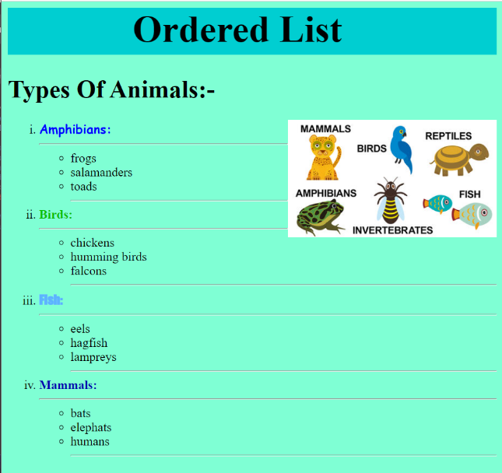

# **QUESTION 3.**

* **HTML CODES:-**

<!DOCTYPE html>

<html>

    <head>

        <title>Table</title>

    </head>

    <body bgcolor="lightblue">

        <table border="5" cellspaceing="15" cellpadding="10">

            <caption><b>Student's Details</b></caption>

            <tr>

                <th>Roll No.</th>

                <th>Name</th>

                <th>Qaulification</th>

                <th colspan="2">Hobby</th>

            </tr>

            <tr>

                <td>1</td>

                <td>Abc</td>

                <td colspan="2">12th Pass</td>

                <td>Sketching</td>

            </tr>

            <tr>

                <td>2</td>

                <td>Def</td>

                <td>12th Pass</td>

                <td>Dancing</td>

            </tr>

            <tr>

                <td>3</td>

                <td>Jkl</td>

                <td height="100">12th Pass</td>

                <td width="100">Singing</td>

            </tr>

            <tr>

                <td>4</td>

                <td>Pqr</td>

                <td>12th Pass</td>

                <td rowspan="2">Blogging</td>

            </tr>

            <tr><td></td></tr>

        </table>

    </body>

</html>

* **OUTPUT:-**

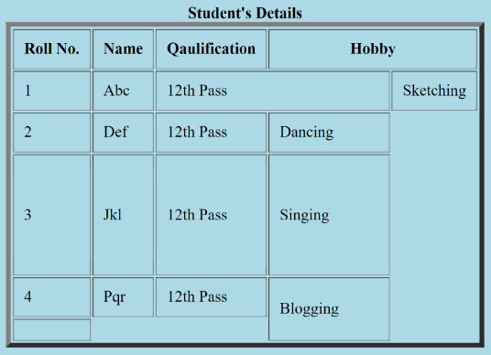

# **QUESTION 4.**

# ***Frame:***

* **HTML CODES:-**

<!DOCTYPE html>

<html>

    <head>

        <title>Frame</title>

    </head>

    <frameset cols="20%,*">

        <frame name="frame1" src="mainmenu.html"></frame>

    <frameset rows="80%,20%">

        <frame name="frame2"></frame>

        <frame name="frame3"></frame>

    </frameset>

    </frameset>

</html>

# ***Main Menu:***

* **HTML CODES:-**

<!DOCTYPE html>

<html>

    <head>

        <title>Main Menu</title>

    </head>

    <body bgcolor="#00bfff">

        <h1><u>Economic Sectors</u></h1>

        <h2><a href="tp1.html" target="frame2">TOPIC 1</a></h2>

        <h2><a href="tp2.html" target="frame2">TOPIC 2</a></h2>

        <h2><a href="tp3.html" target="frame2">TOPIC 3</a></h2>

    </body>

</html>

* **OUTPUT:-**



# ***Topic 1:***

* **HTML CODES:-**

<!DOCTYPE html>

<html>

    <head>

        <title>Topic 1</title>

    </head>

    <body bgcolor="#e9967a">

        <h1><u>Primary Sector</u></h1>

        The primary sector of the economy includes any industry involved in the extraction and production of raw materials.

        <a href="ex1.html" target="frame3">View Examples</a>

    </body>

</html>

* **OUTPUT:-**

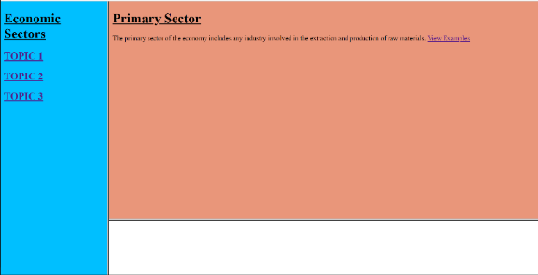

# ***iv. Example 1:***

* **HTML CODES:-**

<!DOCTYPE html>

<html>

    <head>

        <title>Examples</title>

    </head>

    <body bgcolor="#d5d6ea">

        <h1>For Example:</h1>

        Farming, logging, hunting, fishing, forestry and mining.

    </body>

</html>

* **OUTPUT:-**

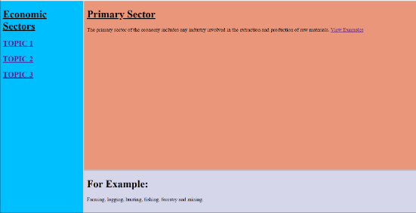

# ***Topic 2:***

* **HTML CODES:-**

<!DOCTYPE html>

<html>

    <head>

        <title>Topic 2</title>

    </head>

    <body bgcolor="#e9967a">

        <h1><u>Secondary Sector</u></h1>

        This sector generally takes the output of the primary sector (i.e. raw materials)

        and creates finished goods suitable for sale to domestic businesses or consumers

        and for export (via distribution through the tertiary sector).

        <a href="ex2.html" target="frame3">View Examples</a>

    </body>

</html>

* **OUTPUT:-**

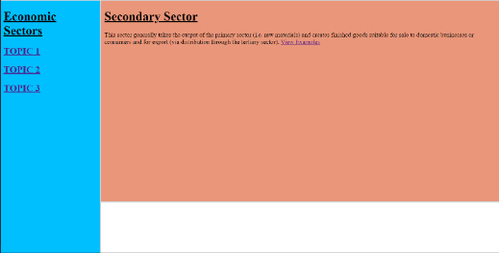

# ***Example 2:***

* **HTML CODES:-**

<!DOCTYPE html>

<html>

    <head>

        <title>Examples</title>

    </head>

    <body bgcolor="#d5d6ea">

        <h1>For Example:</h1>

        Manufacturing.

    </body>

</html>

* **OUTPUT:-**

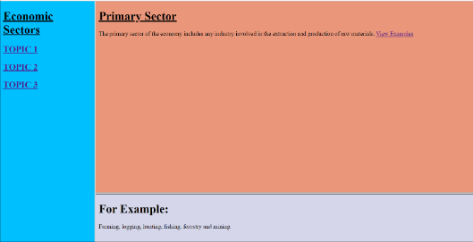

# ***Topic 3:***

* **HTML CODES:-**

<!DOCTYPE html>

<html>

    <head>

        <title>Topic 3</title>

    </head>

    <body bgcolor="#e9967a">

        <h1><u>Tertiary Sector</u></h1>

        The service sector consists of the production of services instead of end products.

        <a href="ex3.html" target="frame3">View Examples</a>

    </body>

</html>

* **OUTPUT:-**

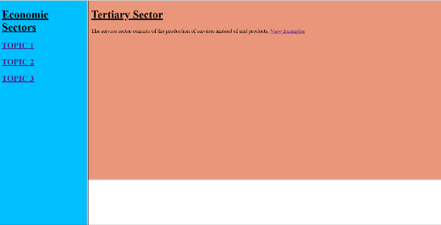

# ***Example 3:***

* **HTML CODES:-**

<!DOCTYPE html>

<html>

    <head>

        <title>Examples</title>

    </head>

    <body bgcolor="#d5d6ea">

        <h1>For Example:</h1>

        Attention, advice, access, experience, and affective labor.

    </body>

</html>

* **OUTPUT:-**

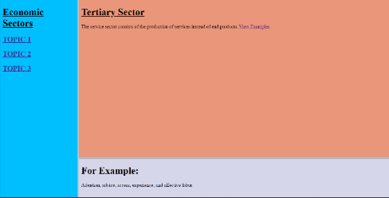

# **QUESTION 5.**

* **HTML CODES:-**

<!DOCTYPE html>

<html>

    <head>

        <title>Image Map</title>

    </head>

    <body bgcolor="gold">

        <img src="Airpods.jpg" usemap="#Airpods" width="400" height="300">

        <map name="#Airpods">

            <area shape="rect" coords="75,325,325,75" alt="#rectangle" href="GoldAirpods.jpeg">

        </mapname>

    </body>

</html>

* **OUTPUT:-**

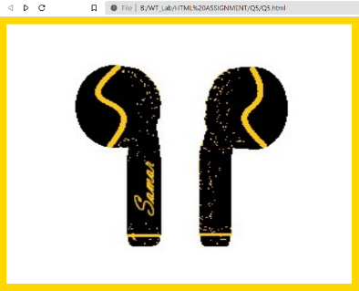



# **QUESTION 6.**

* **HTML CODES:-**

<!DOCTYPE html>

<html>

    <head>

        <title>Registration Form</title>

    </head>

    <body>

        <form>

            <h1><b><u>STUDENTS REGISTRATION FORM</u></b></h1>

            <h1><u>Student Details:</u></h1>

            <label for="fname">Full Name</label>

            <input type="text" id="fname" name="fname"><br><br>

            <label for="father name">Father Name</label>

            <input type="text" id="father name" name="father name"><br><br>

            <label for="mother name">Mother Name</label>

            <input type="text" id="mother name" name="mother name"><br><br>

            <label for="address">Address</label>

            <input type="text" id="address" name="address"><br><br>

            <label for="qualification">Qualification</label>

            <input type="text" id="qualification" name="qualification">

            <h1><u>Hobbies:</u></h1>

            <label for="hobby1">Like Drawing</label>

            <input type="checkbox" id="hobby1" name="hobby1" value="drawing">

<br><br>

            <label for="hobby2">Like Dancing</label>

            <input type="checkbox" id="hobby2" name="hobby1" value="dancing">

            <h1><u>Cources:</u></h1>

            <input type="radio" id="BCA" name="cource name">

            <label for="cource name">BCA</label><br><br>

            <input type="radio" id="BTECH" name="cource name">

            <label for="cource name">BTECH</label><br><br>

            <input type="radio" id="BBA" name="cource name">

            <label for="cource name">BBA</label><br><br>

            <input type="submit" name="submit">

        </form>

    </body>

</html>

* **OUTPUT:-**

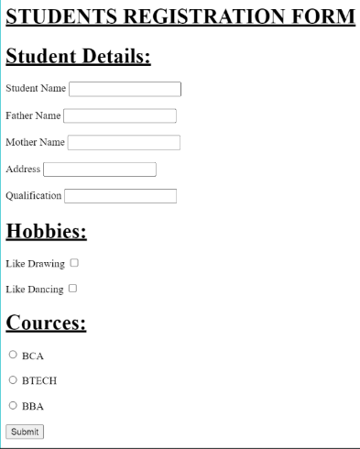

**THE END**